Creating dockerfile: using index.html and base image as ubuntu.

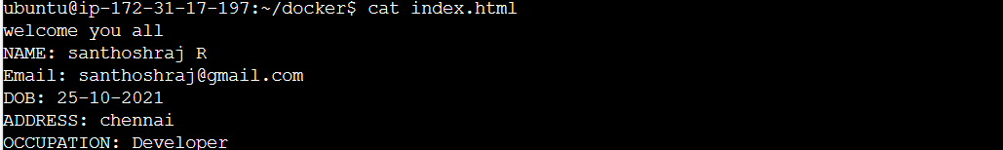

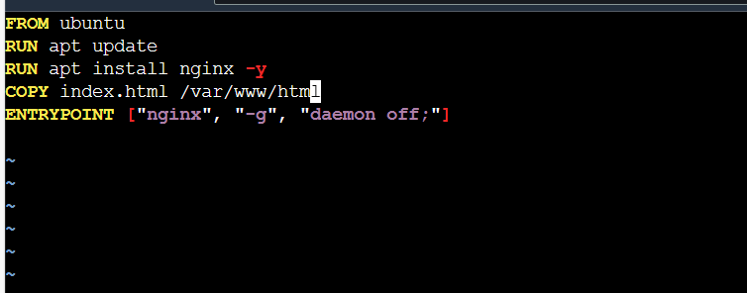

Building docker images using dockerfile

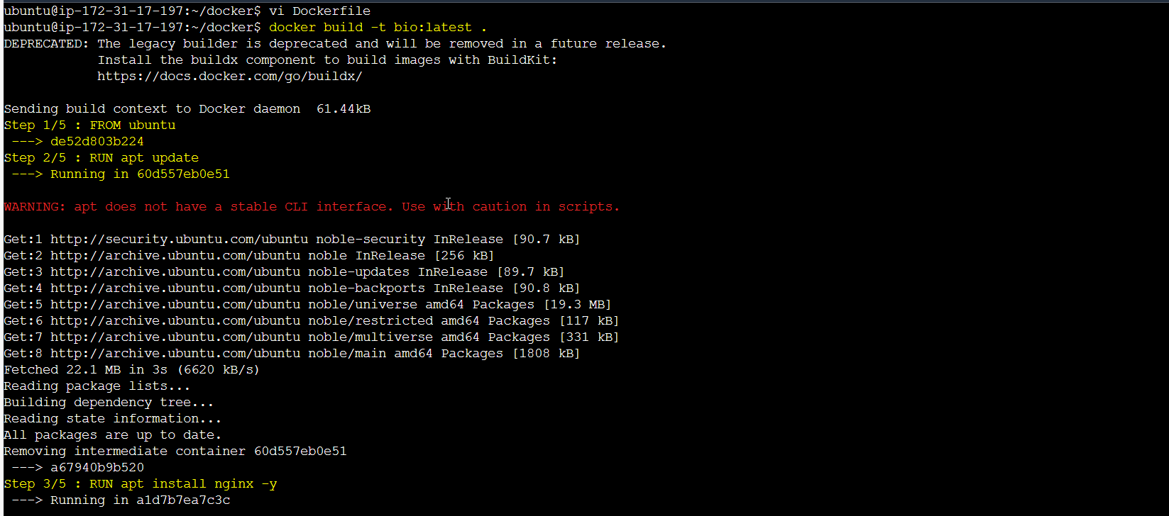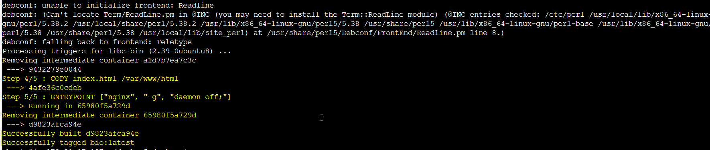

Running the container and it is running without any issue.

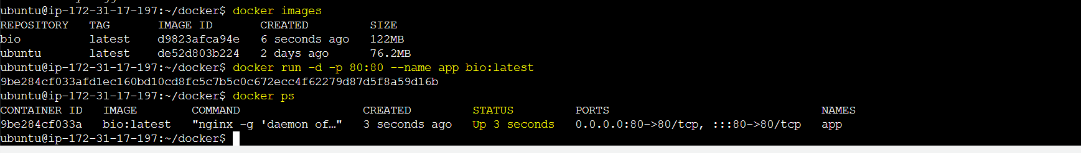

But localhost:80 is not working in EC2 instance

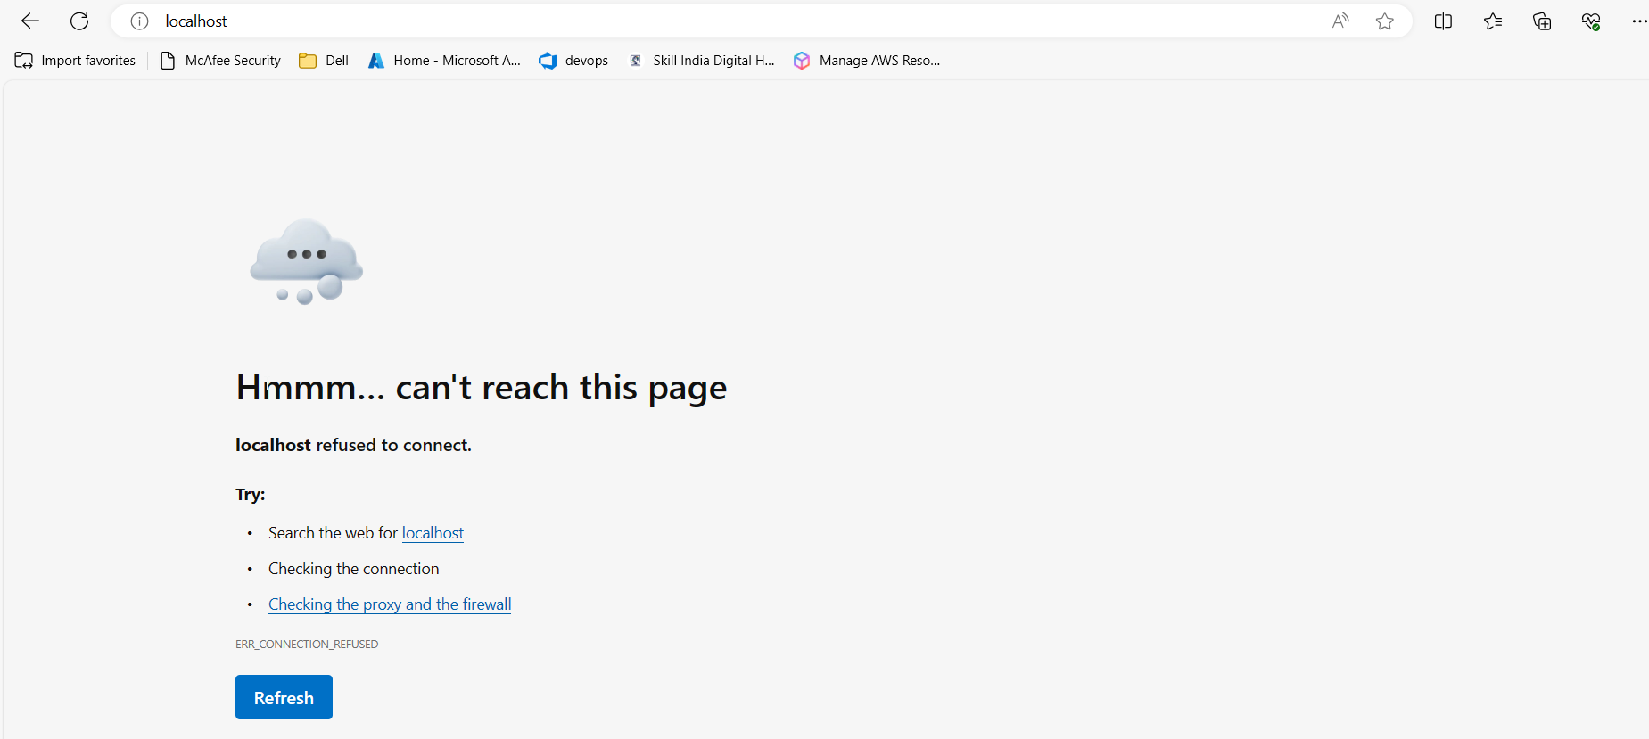

Git push:

